1. 
2. 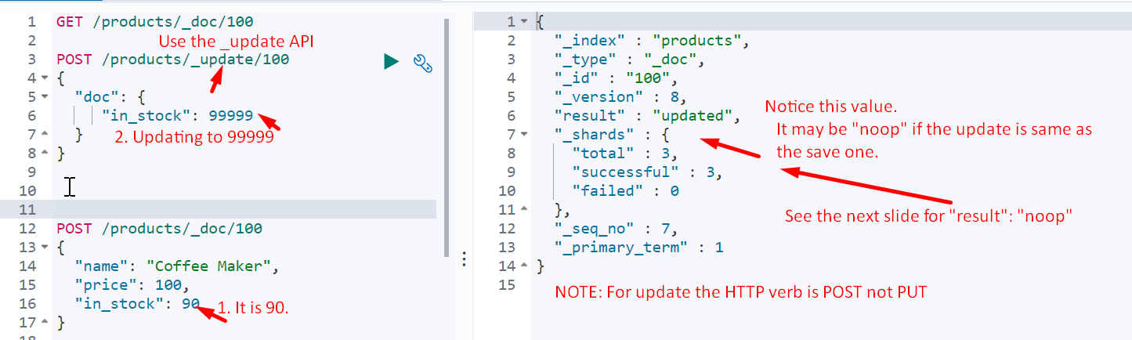
3. 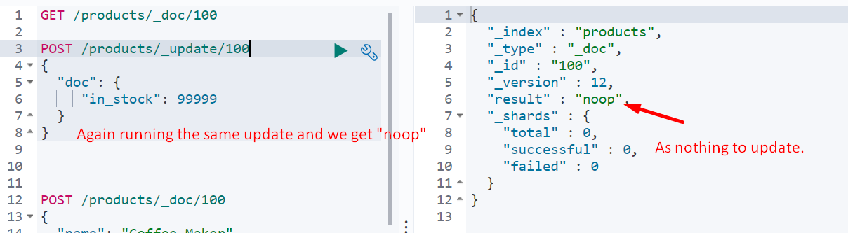
4. Adding a new field during update.
5. 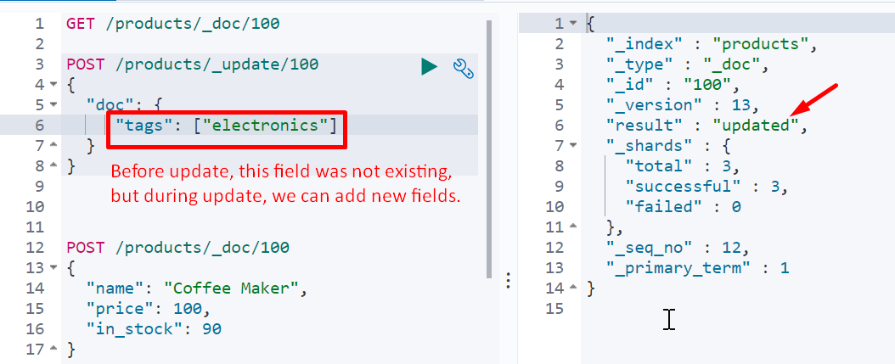
6. Documents are immutable. Meaning each update creates a new document with update values and previous id value and replace the previous one with this one. 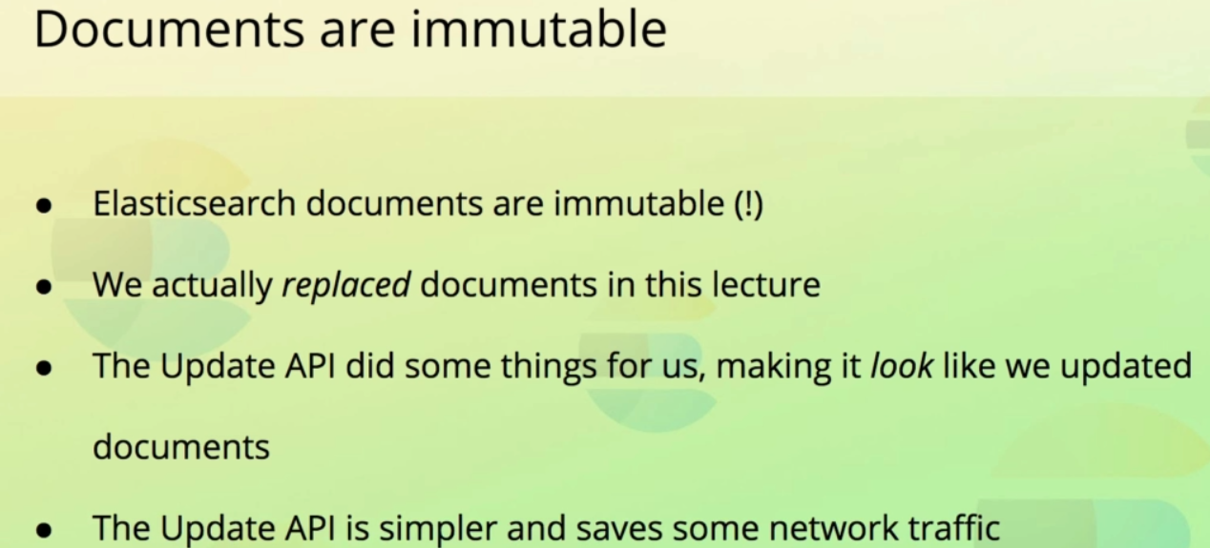
7. 